Table X—Sampling and sex-disaggregation of previous studies of improved cassava-related technology adoption in Nigeria (non-systematic review)

Author | Sample Size | Sample frame | Gender Disaggregation | Gender-Related Results
(Awotide et al. 2014) | 841 HH | Household | - | FHHs more likely to adopt
(Apu and Nwachukwu 2011) | 150 S | Farm families | - | -
(Awotide et al. 2014) | 952 S | Household heads | 89% male  11% female  89% married | Gender not significant
(Agwu, Ekwueme, and Anyanwu 2008) | 135 F | - | 81.5% male  18.5% female  73.3% married | -
(Nwakor et al. 2011) | 150 F | Registered farmers | 45.3% male  54.7% female  70.7% married | Women more likely to adopt
(Obisesan 2014) | 482 HH | Household | 76.23% male  23.8% female | Men more likely to adopt
(Udensi et al. 2011) | 510 F | Community list of Farmers | 43.5% male  56.5% female  78.8% married | Gender not significant in  ICV adoption
(Assfaw Wossen et al. 2017) | 2500 HH | Household heads | - | Men are more likely to adopt. ICV except when adoption is measured by DNA fingerprinting
Notes: F: Farmers, HH: Households, S: Surveys.

Table X—Summary statistics for the Household Cassava Dataset
Category | Variable | Male |  | Female
 |  | N | % | N | %
Marital Status | Married, living with spouse/s | 729 | 100.00% | 729 | 100.00%
Relationship to Household | Head | 726 | 99.59% | 13 | 1.80%
 | Spouse | 3 | 0.41% | 716 | 98.20%
Main Occupation | Farmer (crop and livestock) | 588 | 80.70% | 490 | 67.20%
 | Self-employed off farm | 81 | 11.10% | 160 | 21.90%
 | Other | 60 | 8.20% | 79 | 10.90%
Zone | 1 | 186 | 25.50% | 186 | 25.50%
 | 2 | 238 | 32.60% | 238 | 32.60%
 | 3 | 165 | 22.60% | 165 | 22.60%
 | 4 | 140 | 19.20% | 140 | 19.20%

The mean differences by gender presented in Table X show that the mean of the Y/N ICV variable is higher for husbands than for wives in three of the four zones (Zone 2, 3, and 4). This further confirms that husbands are likelier to report that their household has adopted the new agricultural technology than wives.

Overall, the table suggests that there are non-classical measurement errors in technology adoption reporting, with women being more likely to underreport their adoption than men. This is likely due to several factors, such as gendered social norms and biases, as well as a lack of access to information and resources.

Table X—Descriptive statistics and results from the test and mean differences by gender
 | Household | Husbands | Wives | Test statistics
Variable description. | [1] | [2] | [3] | [1]-[2]. | [1]-[3]. | [2]-[3].
Dependent variables.
Y/N ICV.
All observations. | 0.645 | 0.621 | 0.582 | 0.977 | 2.598*** | 2.224**
Zone 1. | 0.597 | 0.64 | 0.656 | -0.905 | -1.209 | -0.419
Zone 2. | 0.693 | 0.697 | 0.597 | -0.094 | 2.142** | 2.755***
Zone 3. | 0.503 | 0.37 | 0.358 | 2.639*** | 2.810*** | 0.47
Zone 4. | 0.793 | 0.764 | 0.721 | 0.631 | 1.59 | 1.227
All observations. | 1.775 | 1.512 | 1.39 | 4.355*** | 4.921*** | 1.828*
Zone 1. | 1.586 | 1.204 | 1.333 | 4.342*** | 1.961* | -1.164
Zone 2. | 1.66 | 1.773 | 1.555 | -1.375 | 0.722 | 1.690*
Zone 3. | 1.909 | 1.267 | 1.055 | 3.481*** | 4.400*** | 1.29
Zone 4. | 2.064 | 1.764 | 1.579 | 2.379** | 3.334*** | 1.622
Independent variables
Managed plots
Male Managed. |  | 0.978 | 0.621 |  |  | 6.026***
Female Managed. |  | 0.095 | 0.276 |  |  | -5.875***
Joint Managed. |  | 1.414 | 1.656 |  |  | -3.276***
Household Plots. |  | 2.506 | 2.565 |  |  | -1.181
Cassava Plot Size (K). |  | 12.683 | 7.68 |  |  | 6.487***
Income from Cassava (\%). |  | 3.133 | 3.173 |  |  | -0.873
Membership of a coop
Household. |  | 0.262 | 0.296 |  |  | -1.699*
Men Only. |  | 0.067 | 0.091 |  |  | -1.847*
Women Only. |  | 0.016 | 0.029 |  |  | -1.734*
Joint Coop. |  | 0.176 | 0.178 |  |  | -0.147
Credit Access
Household. |  | 0.451 | 0.379 |  |  | 3.193***
Male Only. |  | 0.112 | 0.043 |  |  | 5.163***
Female Only. |  | 0.018 | 0.033 |  |  | -1.862*
Joint Credit. |  | 0.321 | 0.303 |  |  | 0.804
Processing Access
Male Processing Access. |  | 0.232 | 0.254 |  |  | -0.665
Female Processing Access. |  | 0.743 | 1.126 |  |  | -6.269***
Joint Processing Access. |  | 1.753 | 1.136 |  |  | 8.775***
Household Asset Value (M)
Male Owned. |  | 108.519 | 5.323 |  |  | 3.939***
Female Owned. |  | 4.529 | 1.803 |  |  | 1.057
Total Household. |  | 113.06 | 5.504 |  |  | 3.965***
Production Asset Value (K)
Male Value. |  | 1484.778 | 359.289 |  |  | 0.808
Female Value. |  | 6.732 | 8.178 |  |  | -0.618
Total Value. |  | 1493.651 | 260.541 |  |  | 0.888
Household attributes
Age. |  | 50.543 | 40.435 |  |  | 28.879***
Education. |  | 9.342 | 8.029 |  |  | 6.858***
Main occupation. |  | 1.148 | 2.045 |  |  | -7.259***
Contribution to farm work (\%). |  | 80.206 | 70.089 |  |  | 8.646***
Men In House. |  | 2.314 | 2.1 |  |  | 4.918***
Women In House. |  | 2.23 | 2.169 |  |  | 1.491
Kids. |  | 2.763 | 2.599 |  |  | 2.135**
Notes: Robust standard errors in parentheses ***p < 0.01, **p < 0.05, *p < 0.1.

Figure X shows the Comparison between the distributions between Household DNA-Fingerprinting, Male and Female datasets for the Y/N ICV and ICV Total variables. The Y/N ICV variable is a binary variable that indicates whether a household has adopted a new agricultural technology. The ICV Total variable is a continuous variable that measures the intensity of adoption of the new technology. Moreover, the Figure suggests that there may be non-classical measurement errors in the reporting of technology adoption. Specifically, women are more likely to underreport the intensity of their household's adoption of the new technology.

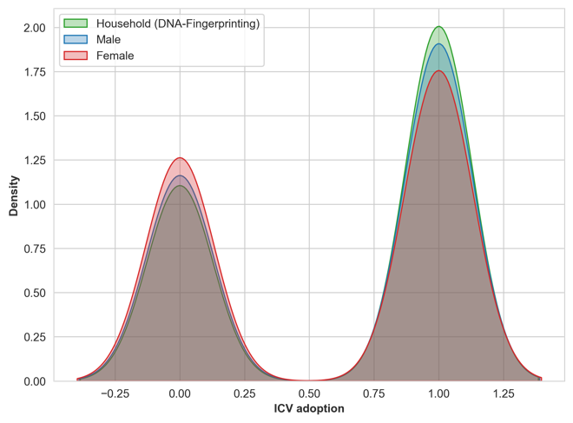 | 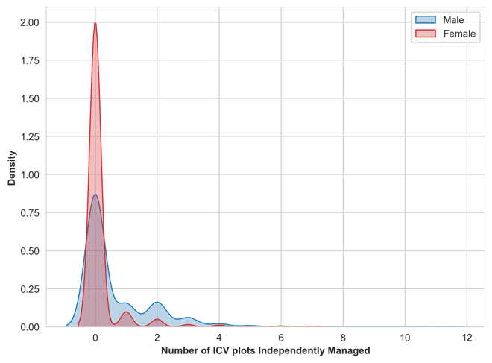
Figure X. The comparison of the self-reported data and DNA fingerprinting test (left) and the Number of ICV plots Independently Managed (right)

Figure X shows the Montecarlo simulation results for different percentages of females. The graph shows a negative correlation between the adoption rate and the percentage of females for the entire population and each zone (except in Zone 1). This means that, in general, areas with a higher percentage of females are less likely to have a higher adoption rate.

The Figure also reveals some interesting zone-specific patterns. For example, Zone 4 has the highest adoption rate across all percentages of females, while Zone 3 has the lowest adoption rate. This suggests that Zone 4 is more receptive to new technologies and innovations, while Zone 3 is more resistant. Additionally, the rate at which the adoption rate increases with the percentage of females varies across zones. For example, in Zone 1, it is the only zone that shows an increment in the adoption rate with the percentage of females, while in the other Zones, the adoption rate decreases slowly. This suggests that there may be different factors driving adoption in different zones.

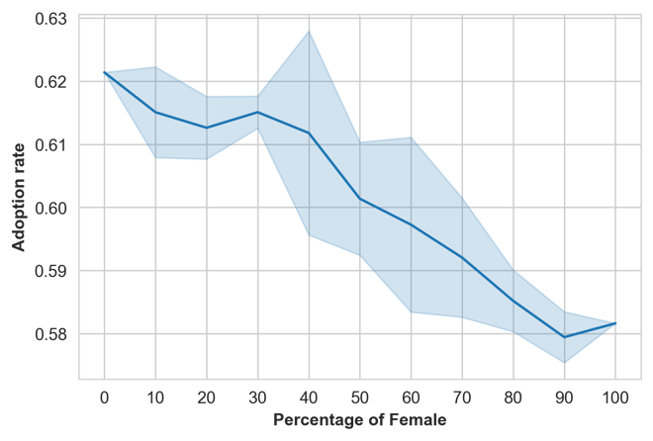 | 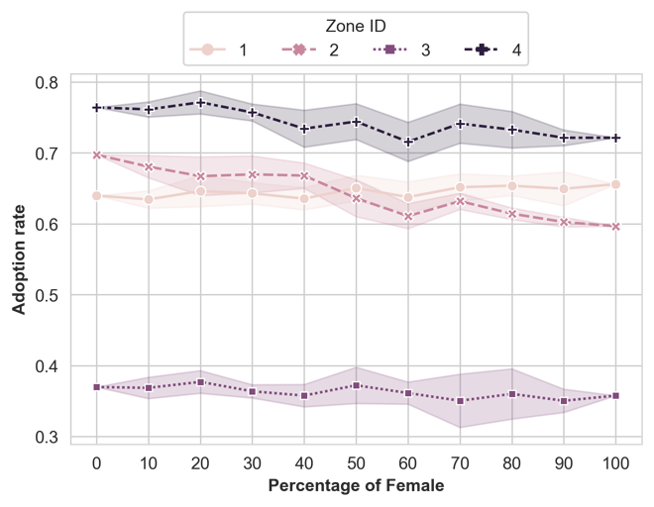
5 iterations of each percentage of female

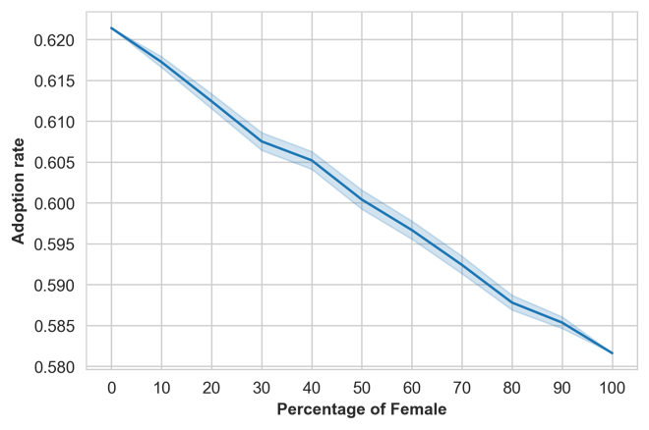 | 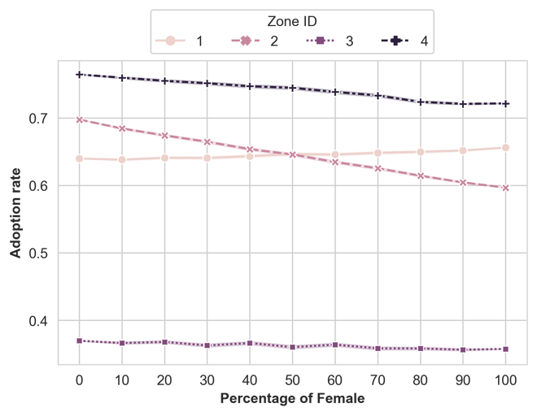
500 iterations of each percentage of female

Figure X: Montecarlo simulation results for different percentages of females.

Table X shows the Probit results with self-reported and DNA fingerprint adoption as the dependent variable. The coefficients for Zone 4 are all positive and statistically significant, while the coefficient for Zone 3 is for all models. These results suggest that there is a relationship between adoption and zone, but the nature of the relationship varies by gender. Also, the Extension Access, use of Fertilizer, and Household size are key determinants of adopting the Male dataset (for the female dataset are the consumption and the salaried employment)

Table X— Male and Female regression with the self-reported and DNA fingerprint adoption as the dependent variable.

 | Male |  | Female
 | Self-reported | DNA fingerprint | Self-reported | DNA fingerprint
Joint Coop | 0.115* | 0.002 | 0.091 | -0.056
 | (0.062) | (0.162) | (0.098) | (0.065)
Household Credit | -0.049 | -0.033 | -0.005 | 0.099
 | (0.066) | (0.125) | (0.106) | (0.143)
Extension Access | 0.427*** | 0.210** | 0.084 | -0.122
 | (0.062) | (0.096) | (0.109) | (0.141)
Cellphone | 0.268 | -0.086 | 0.027 | -0.075
 | (0.427) | (0.342) | (0.213) | (0.457)
Fertilizer | 0.091*** | 0.247* | -0.128 | 0.122
 | (0.022) | (0.146) | (0.112) | (0.172)
Consumption (%) | -0.002 | -0.001 | -0.004*** | 0.002
 | (0.004) | (0.008) | (0.001) | (0.002)
Zone 1 | -0.138*** | 0.186*** | -0.203*** | -0.165**
 | (0.029) | (0.052) | (0.039) | (0.073)
Zone 3 | -0.703*** | -0.643*** | -0.429*** | -0.593***
 | (0.050) | (0.087) | (0.035) | (0.070)
Zone 4 | 0.297*** | 0.318*** | 0.377*** | 0.321***
 | (0.069) | (0.117) | (0.046) | (0.052)
Age | 0.002 | 0.003 | 0.008*** | 0.015***
 | (0.005) | (0.008) | (0.002) | (0.004)
Education | -0.010 | 0.006 | 0.002 | 0.012
 | (0.008) | (0.019) | (0.022) | (0.016)
Household size | 0.068*** | 0.049** | -0.004 | -0.014
 | (0.018) | (0.024) | (0.012) | (0.034)
Salaried employment | -0.143 | -0.094 | 0.300** | -0.009
 | (0.230) | (0.290) | (0.151) | (0.319)
const | -0.257 | -0.132 | 0.114 | -0.183
 | (0.384) | (0.650) | (0.368) | (0.502)
N | 729 | 729 | 729 | 729

Table X— Oaxaca-blinder decomposition: Female vs Male.

Male vs. female
Female | 0.167
Male | 0.647
Mean gender gap | -0.480 ***
 | Endowments | Coefficients | Interaction
Agregate decomposition | -0.053 | -0.462 *** | 0.035
 | (0.052) | (0.057) | (0.057)
Share of the gap | 11.04% | 96.25% | -7.29%
Detailed decomposition
constant | 0.000 | -0.532 ** | -0.000
 | (0.000) | (0.241) | (0.000)
Coop_self | -0.009 | -0.030 ** | 0.017 *
 | (0.008) | (0.013) | (0.009)
Household Credit | 0.002 | -0.002 | 0.000
 | (0.007) | (0.047) | (0.009)
Extension_Access_self | -0.044 * | -0.091 *** | 0.087 ***
 | (0.026) | (0.032) | (0.031)
Cell_Own_self | 0.017 * | 0.161 *** | -0.037 ***
 | (0.010) | (0.055) | (0.013)
Fertilizer | 0.000 | 0.029 | -0.000
 | (0.002) | (0.034) | (0.003)
Consumption (%) | 0.004 | 0.149 | -0.004
 | (0.005) | (0.102) | (0.006)
Zone 1 | -0.000 | 0.013 | 0.000
 | (0.002) | (0.020) | (0.002)
Zone 3 | -0.000 | 0.018 | 0.000
 | (0.004) | (0.024) | (0.003)
Zone 4 | -0.000 | 0.036 * | 0.000
 | (0.004) | (0.019) | (0.004)
Age | 0.006 | 0.287 | -0.057
 | (0.032) | (0.230) | (0.046)
Education | -0.014 | -0.062 | 0.009
 | (0.015) | (0.121) | (0.017)
Household size | -0.016 * | -0.335 ** | 0.020 *
 | (0.009) | (0.133) | (0.012)
Main occupation: Salaried employment | -0.001 | 0.001 | 0.000
 | (0.004) | (0.012) | (0.005)
(Base) | -0.000 | -0.103 *** | 0.000
 | (0.011) | (0.031) | (0.009)

